Steps to execute transaction ZDOCSEARCH

Execute transaction ZDOCSEARCH. The below screen is obtained:

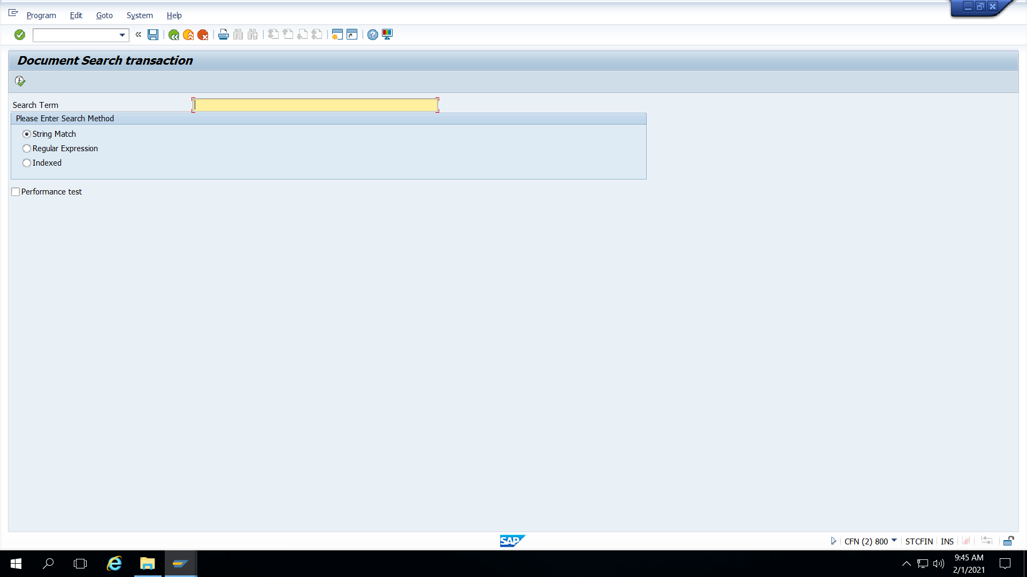

Step 1 : Enter the search term above

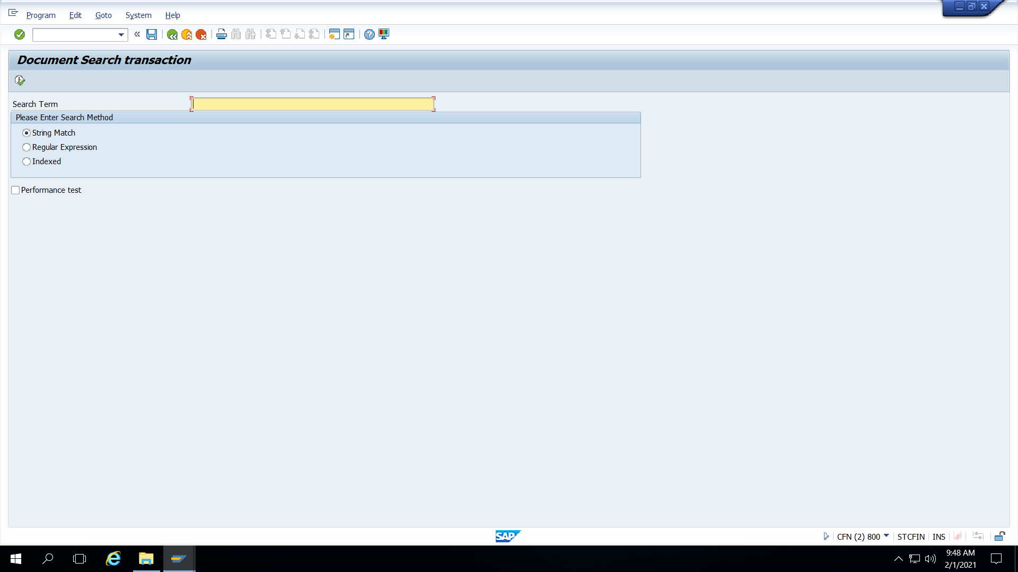

Step 2 : Choose the Search method above as Simple Match, Regular Expression

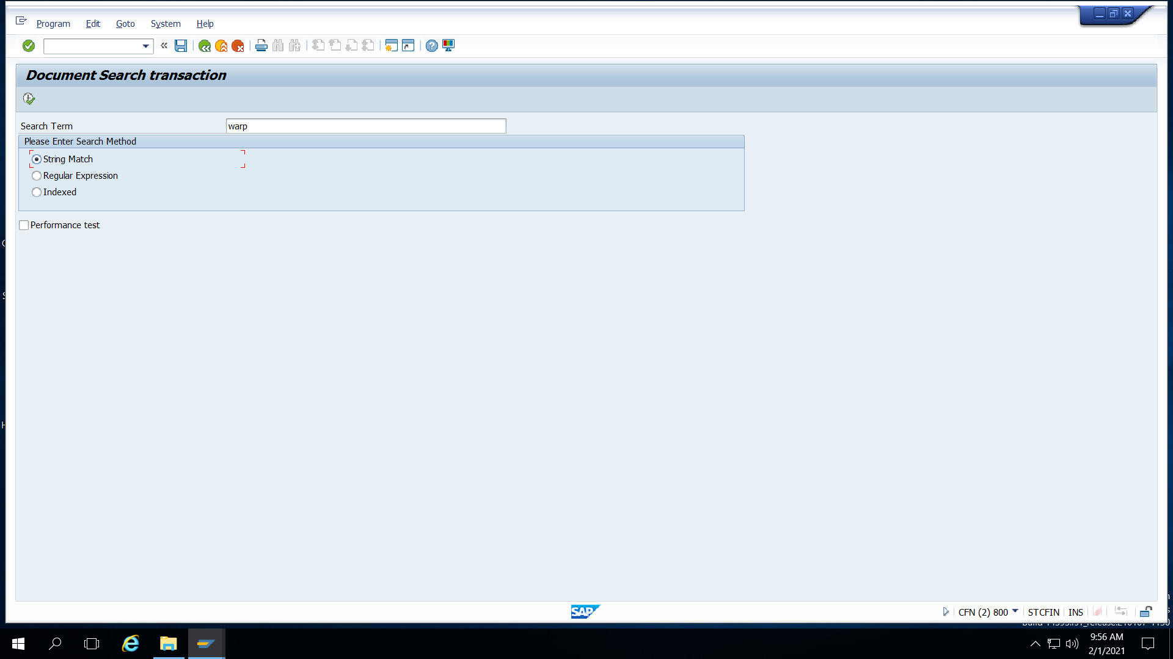

Step 3 : Enter the Search term and Search method and click on Execute

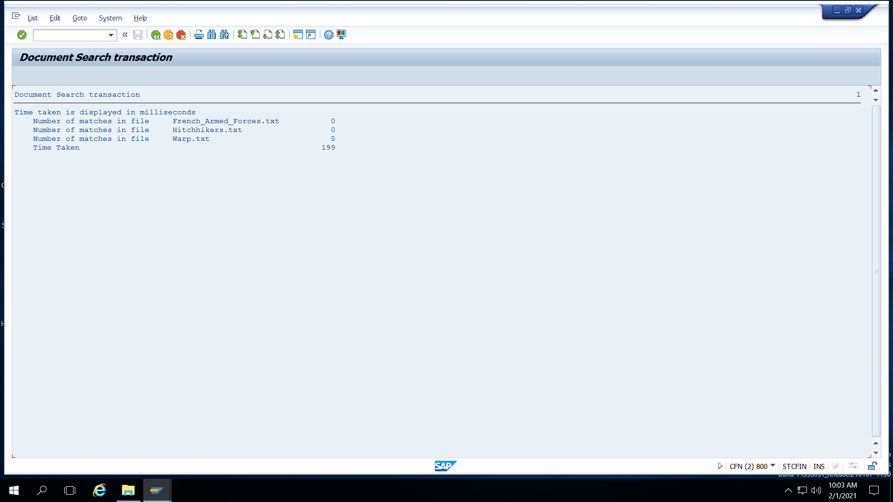

Step 4 : Result displayed above